Single Area OSPF

*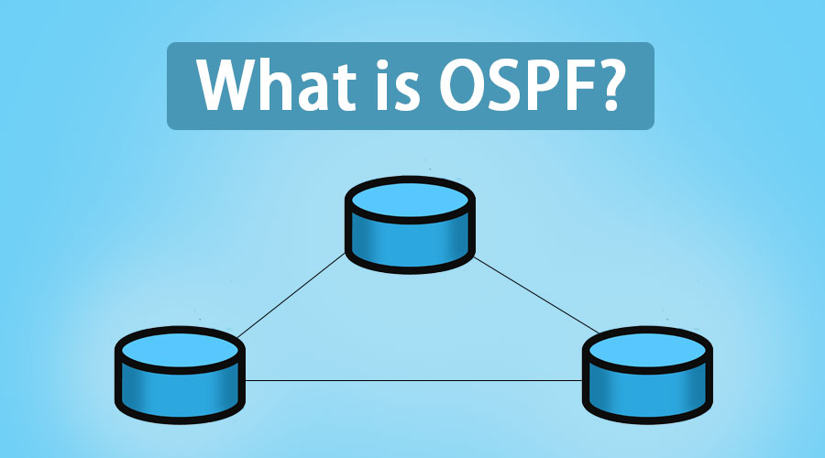idk*

*Austin Tran-Struthers*

**

*Purpose*

To review how to configure single area OSPF within a network.

*Background*

OSPF or open shortest path first is a routing protocol which takes information from all the routers in an area to create a topology. OSPF can support large networks with multiple routers, along with backup routers so it can balance traffic to multiple links in other subnets. OSPF can support IPV4 as well as IPV6 networks. There are 7 states of

*Lab summary*

We used 5 routers to create a network that used ipv4 and ipv6 to connect together in a single area of OSPF.

*Lab Commands*

**router osfp** used to enter router config

**ipv6 router ospf** used to enter ipv6 router config

**network** used to define the subnet in an area

**router-id** used to configure the router id for that specific router

*Network Diagram*

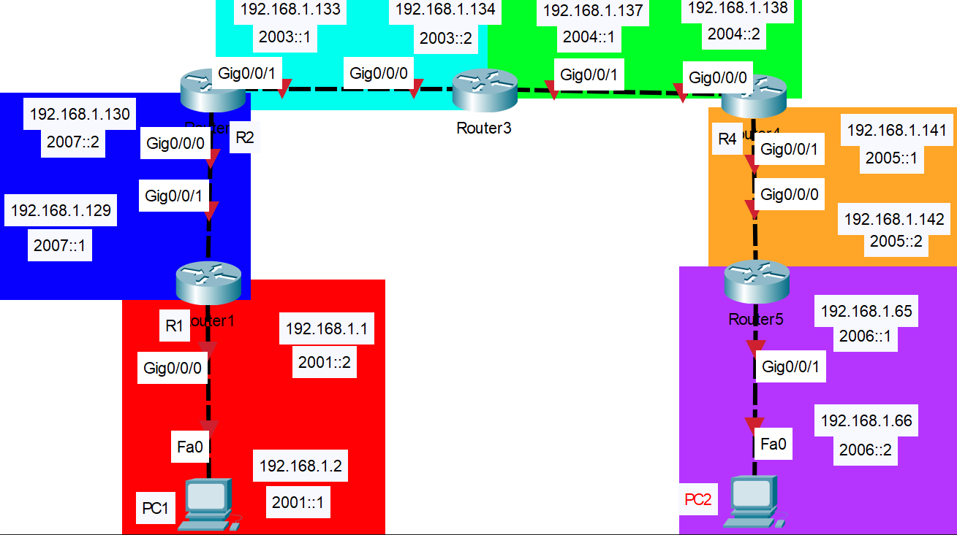

*Router Configurations*

*R1:*

Last configuration change at 22:30:08 UTC Thu Sep 8 2022

version 15.5

service timestamps debug datetime msec

service timestamps log datetime msec

no platform punt-keepalive disable-kernel-core

hostname R1

boot-start-marker

boot-end-marker

vrf definition Mgmt-intf

address-family ipv4

exit-address-family

address-family ipv6

exit-address-family

no aaa new-model

ipv6 unicast-routing

subscriber templating

multilink bundle-name authenticated

license udi pid ISR4321/K9 sn FDO21482HZX

spanning-tree extend system-id

redundancy

mode none

vlan internal allocation policy ascending

interface GigabitEthernet0/0/0

ip address 192.168.1.129 255.255.255.252

ip ospf 1 area 0

negotiation auto

ipv6 address 2002::1/64

ipv6 address 2007::1/64

ipv6 ospf 1 area 0

interface GigabitEthernet0/0/1

ip address 192.168.1.1 255.255.255.192

ip ospf 1 area 0

negotiation auto

ipv6 address 2001::2/64

ipv6 ospf 1 area 0

interface Serial0/1/0

no ip address

shutdown

interface Serial0/1/1

no ip address

shutdown

interface GigabitEthernet0

vrf forwarding Mgmt-intf

no ip address

shutdown

negotiation auto

interface Vlan1

no ip address

shutdown

router ospf 1

network 192.168.1.0 0.0.0.63 area 0

network 192.168.1.128 0.0.0.3 area 0

ip forward-protocol nd

no ip http server

no ip http secure-server

ip tftp source-interface GigabitEthernet0

ipv6 router ospf 1

router-id 1.1.1.1

control-plane

line con 0

stopbits 1

line aux 0

stopbits 1

line vty 0 4

login

end

*R2:*

hostname R2

boot-start-marker

boot-end-marker

vrf definition Mgmt-intf

address-family ipv4

exit-address-family

address-family ipv6

exit-address-family

no aaa new-model

ipv6 unicast-routing

subscriber templating

multilink bundle-name authenticated

license udi pid ISR4321/K9 sn FDO21482DWJ

spanning-tree extend system-id

redundancy

mode none

vlan internal allocation policy ascending

interface GigabitEthernet0/0/0

description To R1 G0/0/1

ip address 192.168.1.133 255.255.255.252

ip ospf 1 area 0

negotiation auto

ipv6 address 2003::1/64

ipv6 ospf 1 area 0

interface GigabitEthernet0/0/1

description Connects to R3 G0/0/0

ip address 192.168.1.130 255.255.255.252

ip ospf 1 area 0

negotiation auto

ipv6 address 2002::2/64

ipv6 address 2007::2/64

ipv6 ospf 1 area 0

interface Serial0/1/0

interface Serial0/1/1

interface GigabitEthernet0

vrf forwarding Mgmt-intf

no ip address

shutdown

negotiation auto

interface Vlan1

no ip address

shutdown

router ospf 1

network 192.168.1.128 0.0.0.3 area 0

network 192.168.1.132 0.0.0.3 area 0

ip forward-protocol nd

no ip http server

no ip http secure-server

ip tftp source-interface GigabitEthernet0

ipv6 router ospf 1

router-id 2.2.2.2

control-plane

line con 0

stopbits 1

line aux 0

stopbits 1

line vty 0 4

login

end

*R3:*

hostname R3

boot-start-marker

boot-end-marker

vrf definition Mgmt-intf

address-family ipv4

exit-address-family

address-family ipv6

exit-address-family

no aaa new-model

ipv6 unicast-routing

subscriber templating

vtp domain cisco

vtp mode transparent

multilink bundle-name authenticated

license udi pid ISR4321/K9 sn FDO214420HW

spanning-tree extend system-id

Redundancy

mode none

vlan internal allocation policy ascending

interface GigabitEthernet0/0/0

description Connects to R2 G0/0/1

ip address 192.168.1.137 255.255.255.252

ip ospf 1 area 0

negotiation auto

ipv6 address 2004::1/64

ipv6 ospf 1 area 0

interface GigabitEthernet0/0/1

description Connects to R4 G0/0/0

ip address 192.168.1.134 255.255.255.252

ip ospf 1 area 0

negotiation auto

ipv6 address 2003::2/64

ipv6 ospf 1 area 0

interface Serial0/1/0

no ip address

shutdown

interface Serial0/1/1

no ip address

shutdown

interface GigabitEthernet0

vrf forwarding Mgmt-intf

no ip address

shutdown

negotiation auto

interface Vlan1

no ip address

shutdown

router ospf 1

network 192.168.1.132 0.0.0.3 area 0

network 192.168.1.136 0.0.0.3 area 0

ip forward-protocol nd

no ip http server

no ip http secure-server

ip tftp source-interface GigabitEthernet0

ipv6 router ospf 1

router-id 3.3.3.3

control-plane

line con 0

stopbits 1

line aux 0

stopbits 1

line vty 0 4

login

end

*R4:*

hostname R4

boot-start-marker

boot-end-marker

vrf definition Mgmt-intf

address-family ipv4

exit-address-family

address-family ipv6

exit-address-family

no aaa new-model

ipv6 unicast-routing

subscriber templating

vtp domain cisco

vtp mode transparent

multilink bundle-name authenticated

license udi pid ISR4321/K9 sn FDO214421D1

spanning-tree extend system-id

redundancy

mode none

vlan internal allocation policy ascending

interface GigabitEthernet0/0/0

description Connects R3 G0/0/1

ip address 192.168.1.141 255.255.255.252

ip ospf 1 area 0

negotiation auto

ipv6 address 2005::1/64

ipv6 ospf 1 area 0

interface GigabitEthernet0/0/1

description Connects to R5 g0/0/0

ip address 192.168.1.138 255.255.255.252

ip ospf 1 area 0

negotiation auto

ipv6 address 2004::2/64

ipv6 ospf 1 area 0

interface Serial0/1/0

no ip address

shutdown

interface Serial0/1/1

no ip address

shutdown

interface GigabitEthernet0

vrf forwarding Mgmt-intf

no ip address

shutdown

negotiation auto

interface Vlan1

no ip address

shutdown

router ospf 1

network 192.168.1.136 0.0.0.3 area 0

network 192.168.1.140 0.0.0.3 area 0

ip forward-protocol nd

no ip http server

no ip http secure-server

ip tftp source-interface GigabitEthernet0

ipv6 router ospf 1

router-id 4.4.4.4

control-plane

line con 0

stopbits 1

line aux 0

stopbits 1

line vty 0 4

login

end

*R5:*

hostname R5

boot-start-marker

boot-end-marker

vrf definition Mgmt-intf

address-family ipv4

exit-address-family

address-family ipv6

exit-address-family

no aaa new-model

login on-success log

subscriber templating

ipv6 unicast-routing

multilink bundle-name authenticated

crypto pki trustpoint TP-self-signed-859896477

enrollment selfsigned

subject-name cn=IOS-Self-Signed-Certificate-859896477

revocation-check none

rsakeypair TP-self-signed-859896477

crypto pki certificate chain TP-self-signed-859896477

certificate self-signed 01

3082032E 30820216 A0030201 02020101 300D0609 2A864886 F70D0101 05050030

30312E30 2C060355 04031325 494F532D 53656C66 2D536967 6E65642D 43657274

69666963 6174652D 38353938 39363437 37301E17 0D323230 39303832 31313332

335A170D 33303031 30313030 30303030 5A303031 2E302C06 03550403 1325494F

532D5365 6C662D53 69676E65 642D4365 72746966 69636174 652D3835 39383936

34373730 82012230 0D06092A 864886F7 0D010101 05000382 010F0030 82010A02

82010100 C9F225AF 4B6ADF33 559D4FF7 F0AFF96B 4C37D734 5BE541CE 17408F3E

A2AD8FD2 BD3F7809 40BD3B4D 1592F042 7EAC48F1 DC1DF153 A25CBC8D 6A6D17C4

F503BC80 BAF3311D ACC92CCE 40458DF5 80AB8937 C1AB4E9E 03CF01FA 3B870FB8

01E5D012 2EA30412 742A21CC EF220F53 57F08197 E1009ACE BEA1DD9A 2EC2B839

48ED23EF B5653A64 5EF7EB16 F333AEFE 2609A60D 60B8B007 4CBB12F2 35D35150

19095CE6 39A4721F 84ECE62C EE05AD90 6941F25A 0589CCA6 15349D8E FDDFE824

A68EDDE2 513CA7CD C876388D D9410FFF 4D8F6B21 DE53029F A3EE9460 35D75FF2

52E235A3 30BC5E52 EA2F890A C983B03A 2BB394BE D13B4F7B EE921365 AE764EE6

DC18EC51 02030100 01A35330 51300F06 03551D13 0101FF04 05300301 01FF301F

0603551D 23041830 16801430 374799BC 5D153388 C26DCA51 5D6B20F4 DD48CC30

1D060355 1D0E0416 04143037 4799BC5D 153388C2 6DCA515D 6B20F4DD 48CC300D

06092A86 4886F70D 01010505 00038201 010014B6 F876F359 B8CF468B A70B3DDE

245D928C FE50B500 56DB2279 C62ECBC2 0D7AAAC1 8BE1A819 5B837A7B 96C877C0

9BACA2A1 611C0729 08A326B5 309FA8B0 BEE7D936 A9E09834 8D92AFBE CE34E692

A2554B17 71DC3B24 FC68B952 26003841 452D57DE B72AE1E8 8FE3FE7B B6B94922

501898A0 550CFA71 C24B5201 EFADE2E0 40353E04 08840B7E F02DECE0 0C0DD2B5

C653752B 97F9919A 226AF7A4 9AB274A4 61297BFC 918FAAC4 12070EE7 29BFCF6D

0EEF9B88 D35AEDF7 7AD6BA0D CE3A734C 4D438388 98CD3D30 48D57E86 06C1B001

586C81E0 8C71678D 905CB5E9 116FFF8F A44F0E3A F9E2E2D3 A4B325CB 215E1FCF

B52A97F2 1A2DCC2B 132A7CD3 EFDE12E1 92BF

quit

license udi pid ISR4321/K9 sn FLM240608PJ

no license smart enable

diagnostic bootup level minimal

spanning-tree extend system-id

redundancy

mode none

interface GigabitEthernet0/0/0

ip address 192.168.1.65 255.255.255.192

negotiation auto

ipv6 address 2006::1/64

ipv6 ospf 1 area 0

interface GigabitEthernet0/0/1

ip address 192.168.1.142 255.255.255.252

negotiation auto

ipv6 address 2005::2/64

ipv6 ospf 1 area 0

interface GigabitEthernet0/1/0

no ip address

shutdown

negotiation auto

interface GigabitEthernet0/1/1

no ip address

shutdown

negotiation auto

interface GigabitEthernet0

vrf forwarding Mgmt-intf

no ip address

shutdown

negotiation auto

router ospf 1

router-id 5.5.5.5

network 192.168.1.64 0.0.0.63 area 0

network 192.168.1.140 0.0.0.3 area 0

ip forward-protocol nd

ip http server

ip http authentication local

ip http secure-server

ip tftp source-interface GigabitEthernet0

ipv6 router ospf 1

router-id 5.5.5.5

control-plane

line con 0

transport input none

stopbits 1

line aux 0

stopbits 1

line vty 0 4

login

end

*Screenshots*

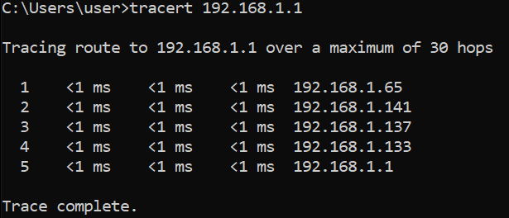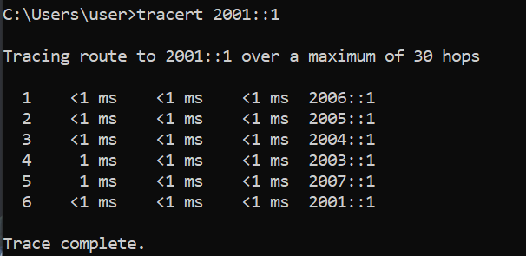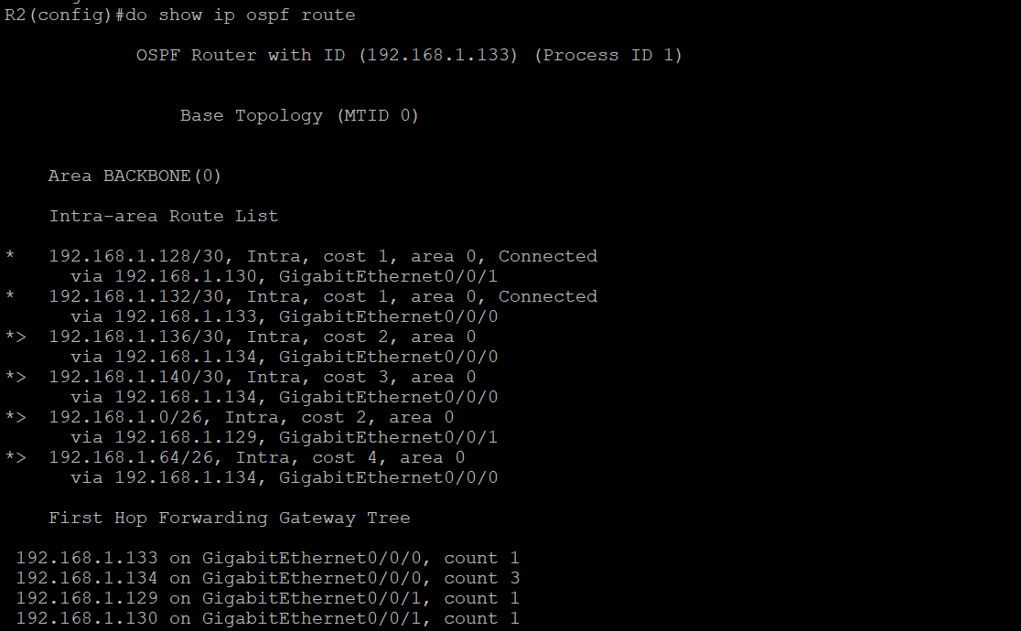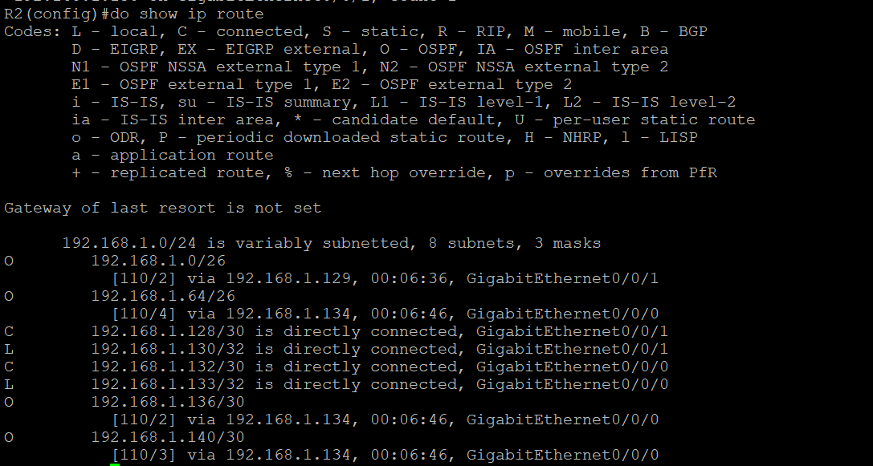

*Problems*

When copying the configurations into the routers we kept forgetting to do the no shutdown command on the routers, but it wasn’t too much of a major issue. We had an incorrect subnet mask on one of the interfaces which caused that interface to not work with the rest of the network. The major problem we had was with our addressing scheme, because we used 2002:: for one of our ipv6 subnets but we forgot that that was a reserved address so we had to change that one specifically to 2007::.

*Conclusion*

During this lab we had to review how to configure single area OSPF. In our situation subnetting wasn’t the best decision because it made everything go much slower.